Failure Diagnosis Module (Hybrid Regex + ML)
Oct 1, 2026 ·

1. Summary
When an Airflow DAG run fails, the diagnosis module reads the failed tasks' logs and picks one of 9 failure categories, plus whether a retry is likely to help. Model 20261001-0630 passed the go/no-go gate and is implemented.
Status | Implemented; model 20261001-0630 passed the go/no-go gate
Plan | aiplan1.md
Owners | Backend (backend/app/diagnosis, backend/app/services/diagnosis_service.py), ML service (ml_service/)
Last updated | 2026-10-01
The diagnosis drives automation: workflow conditions branch on the category, and the retry policy reads retryable. Operators see it at the top of the incident page.
It works in two stages:
- Regex classifier: fast, deterministic, explainable rules. Always run; the default answer.
- ML classifier: a fine-tuned DistilBERT model on a separate GPU service. Consulted only when regex is weak (UNKNOWN or CODE_BUG). It changes the category only when confidence ≥ ML_MIN_CONFIDENCE (default 0.85); otherwise its answer is a display-only suggestion.
Every diagnosis is computed once, when the evidence arrives, and stored on the incident. Page views and workflow runs read the stored value. An operator correction always wins.

2. Why a hybrid?
Regex is cheap and explainable but blind to unseen formats; the model generalises but can be wrong. The hybrid runs the model only where regex is weak and always falls back to regex.
 | Regex alone | Model alone | Hybrid
Speed / cost | Microseconds, no infrastructure | GPU service, ~ms per log | Model only on weak cases
Explainable | Yes (rule name + matched line) | Partly (scores, window) | Yes; source is always recorded
Unseen log formats | Returns UNKNOWN | Generalises | Model fills the gap
Generic ValueError / TypeError | Always CODE_BUG | Reads the context | Model can correct it
Failure mode if broken | n/a | Wrong answers | Falls back to regex
Design principles:
- Prove value first. The model was adopted only after it beat regex on an evaluation set (§9).
- Diagnose once, persist it. No model calls on the request path.
- Automation only acts on trustworthy categories. A low-confidence model output is a suggestion only.
- Regex is always the fallback. ML disabled, down or not ready behaves exactly as before.
- Operators close the loop. Corrections are stored and become labeled training data.

3. Failure categories
Nine categories, four of them retryable. Defined in backend/app/diagnosis/log_classifier.py (FailureCategory); the ML service uses the same list and order (ml_service/app/schemas.py, CATEGORIES).
Category | Label shown to users | Retryable | Typical evidence
AUTH | Login or permission problem | No | password authentication failed, AccessDenied, HTTP 401/403, expired token
DATA_INTEGRITY | Bad data (constraint violation) | No | UniqueViolation, IntegrityError, failed data-quality check
SCHEMA | Table or column changed | No | UndefinedColumn, no such table, invalid identifier
CODE_BUG | Code error | No | NameError, ImportError, AttributeError, KeyError …
RESOURCE | Out of memory or disk | Yes | MemoryError, OOMKilled, exit 137, No space left on device
TIMEOUT | Timeout | Yes | AirflowTaskTimeout, ReadTimeout, statement timeout
TRANSIENT_NETWORK | Network glitch | Yes | Connection refused/reset, DNS failure, 502/503/504, 429
UPSTREAM_MISSING | Missing input | Yes | FileNotFoundError, NoSuchKey, missing partition
UNKNOWN | Unknown | Yes | Nothing matched
retryable is always derived in the backend from the RETRYABLE set. The model never decides it.

4. Architecture
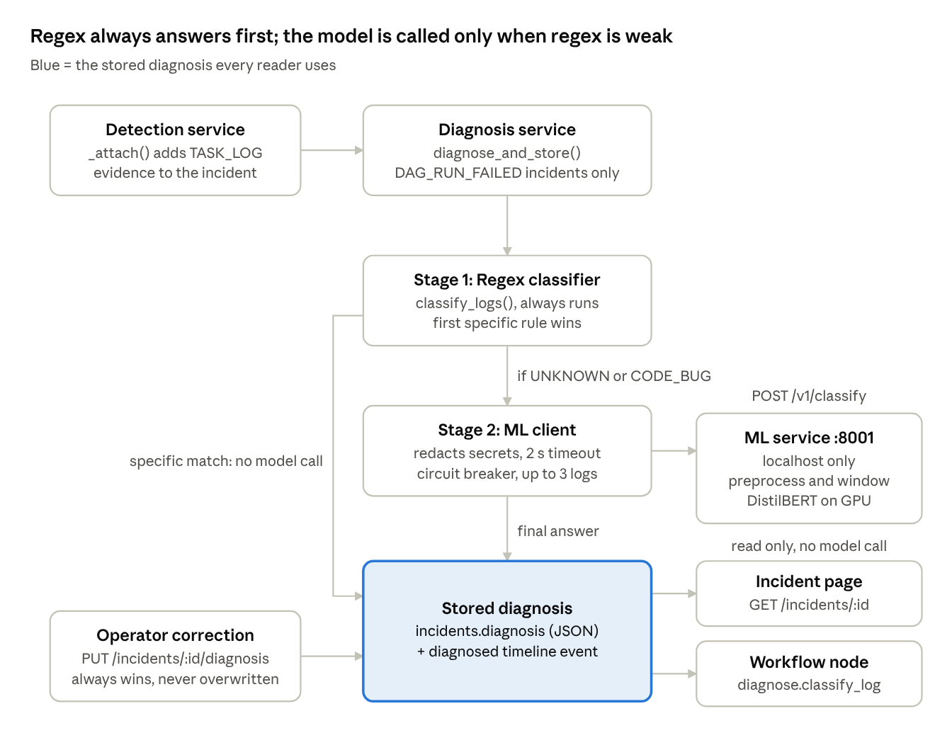
architecture · components and data flow
New log evidence triggers one diagnosis, which is stored; the incident page and workflow node only read it. The Log Analyzer (POST /diagnosis/classify) runs the same regex and model path but stores nothing.
Component | File | Responsibility
Regex classifier | backend/app/diagnosis/log_classifier.py | Ordered rules, first match wins; returns category, confidence, rule, matched line
Hybrid rule | backend/app/diagnosis/hybrid.py | Pure decision function decide(); model client injected
ML client | backend/app/connectors/ml_client.py | Sync HTTP client, secret redaction, payload trimming, circuit breaker
Diagnosis service | backend/app/services/diagnosis_service.py | Diagnose-and-store, backfill, operator override, events, audit
Detection hook | backend/app/services/detection_service.py (_attach) | Triggers diagnosis when new TASK_LOG evidence arrives
Workflow node | backend/app/services/automation_nodes.py (_classify) | Reads the stored diagnosis (computes it only if missing)
API | backend/app/api/v1/incidents.py, backend/app/api/v1/diagnosis.py | Incident detail, correction endpoint, Log Analyzer endpoint
Storage | Incident.diagnosis JSON column; migration c7e2a91f5b30 | Persisted diagnosis
ML service | ml_service/app/ | FastAPI service: preprocessing, model loading, inference
Training | ml_service/training/ | Synthetic data, training, calibration, evaluation
Frontend | DiagnosisCard.jsx, LogAnalyzer.jsx | Incident card, correction dialog, Log Analyzer page

5. How a diagnosis is made
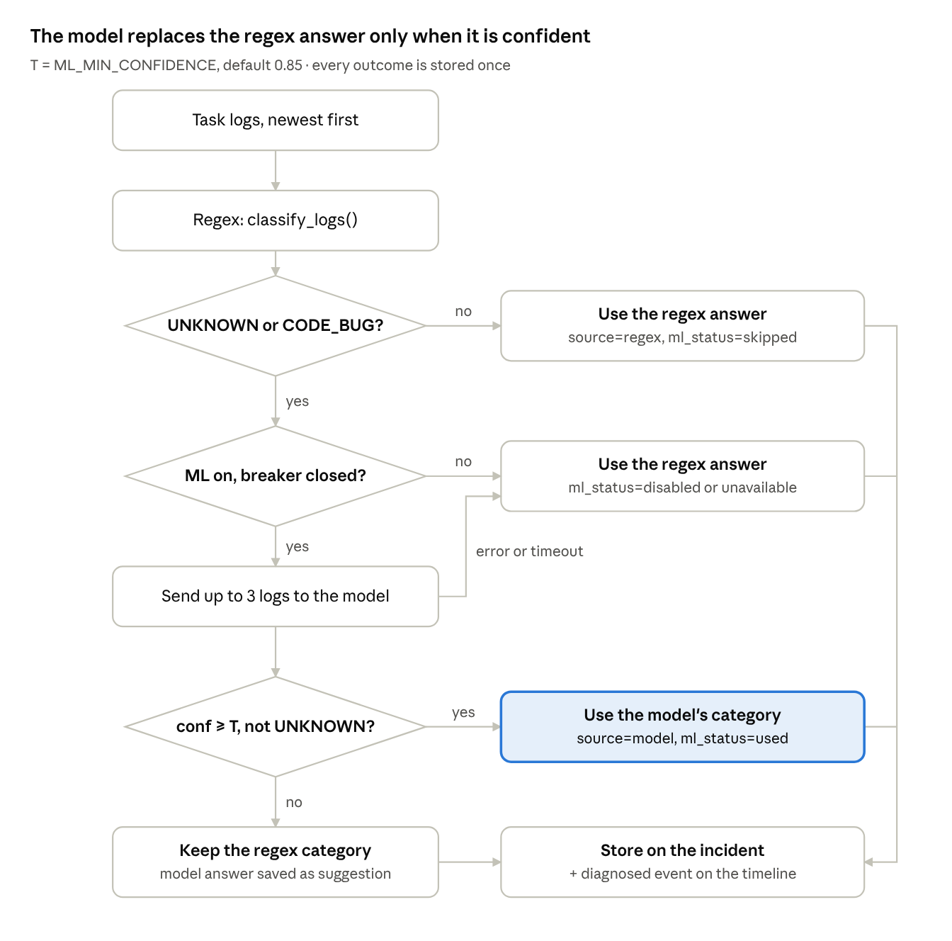
decision rule · 3 checks, 4 outcomes
A specific regex match is final; only a weak result reaches the model, and only a confident model answer replaces it.
- Trigger. The detection service attaches evidence. If any new record is a non-empty TASK_LOG, it calls diagnosis_service.diagnose_and_store().
- Guard. Only DAG_RUN_FAILED incidents are diagnosed. An operator's stored diagnosis is kept unchanged.
- Regex. classify_logs() runs over the incident's logs (newest first) and returns the first specific match.
- Specific answer? Anything other than UNKNOWN/CODE_BUG (e.g. RESOURCE from an OOM line, confidence 0.9) is final. No model call.
- Ask the model. If ML_SERVICE_ENABLED, the client sends up to 3 logs. Secrets are redacted and each log is trimmed to its tail so the request stays under 200 KB.
- Model failure. Timeout, connection error, non-200 or a malformed response raises MLUnavailable; regex is used with ml_status="unavailable". After ML_BREAKER_FAILURES consecutive failures the circuit opens for ML_BREAKER_COOLDOWN_SECONDS and calls fail fast.
- Confident model. If confidence ≥ ML_MIN_CONFIDENCE and the category isn't UNKNOWN, the model's category is final (source="model", rule="model"). matched_line is the model's highest-signal line.
- Unsure model. The regex category stays. A different, known model category is stored as suggestion (display only).
- Persist. The payload goes to incidents.diagnosis, plus a diagnosed timeline event with category, source, confidence, model version and ML status.

Reading the diagnosis
- Incident page (GET /incidents/{id}) returns the stored diagnosis and never calls the model. Incidents created before this feature get a regex-only diagnosis on first read, stored with a diagnosed event marked backfill: true.
- Workflow node diagnose.classify_log uses the stored diagnosis, so the workflow and the incident page always agree. If none is stored yet, it computes and stores one.

Operator correction
PUT /incidents/{id}/diagnosis with {category, note} (Operator or Admin):
- New payload has source="operator", confidence=1.0, corrected_by and note.
- previous records what the system said before the first correction, kept across re-corrections.
- Writes a diagnosis_corrected timeline event and an incident.diagnosis_corrected audit entry.
- Is never overwritten by later re-diagnosis.
- Exported by backend/scripts/export_task_logs.py as operator_category, which makes it labeled training data.

6. Stored diagnosis payload
One JSON object on incidents.diagnosis, schema DiagnosisRead in backend/app/schemas/incident.py.
Field | Type | Meaning
category | str | Final category (one of 3)
label | str | Human-readable label
retryable | bool | From RETRYABLE, never from the model
confidence | float | Regex rule confidence, model probability, or 1.0 for operator
rule | str | null | Regex rule name, "model", "operator", "no_log", "no_rule_matched"
matched_line | str | null | Evidence line shown in the UI and notifications
source | regex | model | operator | Who decided
model_version | str | null | Weights version when the model was consulted
top_predictions | list {category, score} | Model's top-k scores
suggestion | {category, label, confidence} | null | Low-confidence model answer (display only)
ml_status | used | skipped | unavailable | disabled | What happened with the model
diagnosed_at | ISO datetime | When it was computed
note, corrected_by, previous |  | Operator corrections only
Example, a model override of a regex UNKNOWN:
{
"category": "TRANSIENT_NETWORK",
"label": "Network glitch",
"retryable": true,
"confidence": 0.8812,
"rule": "model",
"matched_line": "vendor_client.errors.ApiError: [Errno 111] Connection refused",
"source": "model",
"model_version": "20261001-0630",
"top_predictions": [
{"category": "TRANSIENT_NETWORK", "score": 0.8812},
{"category": "TIMEOUT", "score": 0.0301},
{"category": "AUTH", "score": 0.0175}
],
"suggestion": null,
"ml_status": "used",
"diagnosed_at": "2026-10-01T06:45:12.381Z"
}

7. The ML service (ml_service/)
A standalone FastAPI app that loads the newest weights/<version>/ (or ML_WEIGHTS_VERSION) and runs on the GPU when one is available, otherwise the CPU.
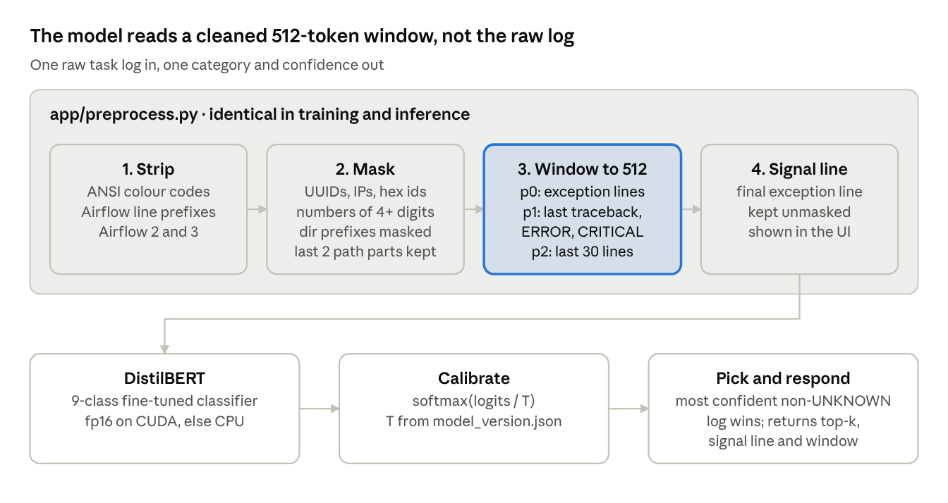
ML service inference path · 4 preprocessing steps, 3 model steps
Windowing packs lines by priority until the 512-token budget is full, de-duplicated and output in original order. With several logs per incident, each is windowed and scored separately.

Model (app/model.py)
- distilbert-base-uncased fine-tuned for 9-class sequence classification.
- fp16 on CUDA inside torch.inference_mode(), with a warm-up call at load.
- Applies the calibration temperature from model_version.json: probs = softmax(logits / T). Older weights default to T = 1.0.
- No zero-shot fallback: without trained weights the service reports ready=false and the backend keeps using regex.

API
Endpoint | Auth | Body / response
GET /v1/health | none | {ready, model_version, device, vram_used_mb}
POST /v1/classify | X-ML-Token header (constant-time compare) | Request {logs: [str] (1–10), top_k: 1–9} → {category, confidence, top_predictions, model_version, signal_line, window, device, inference_ms}
Errors: 401 (missing or bad token; an empty server token rejects everything), 413 (body > 256 KB), 422 (invalid body), 503 (model not ready).
Security: the service binds to 127.0.0.1 by default because logs can contain secrets. The backend also redacts password=, token=, API keys, Authorization/Bearer values and URL credentials before sending.

8. Training pipeline (ml_service/training/)
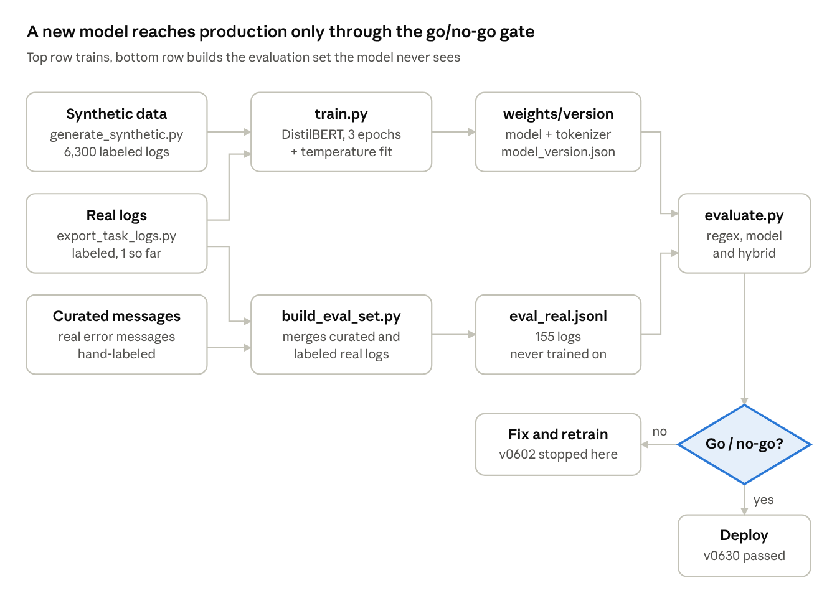
training pipeline · ml_service/training/
Training and evaluation data never mix: the evaluation set is built separately and only evaluate.py reads it.

Data
Dataset | File | Size | Purpose
Synthetic | data/synthetic.jsonl | 6,300 logs from 292 templates (700 per category) | Training + validation
Exported real | data/exported_task_logs.jsonl | 1 log so far | Labeled rows go to training (if not in the eval set)
Evaluation | data/eval_real.jsonl | 155 logs (1 exported, 154 curated) | Go/no-go gate; never trained on
The synthetic generator uses hand-written templates of real library errors (psycopg2, boto3, Snowflake, BigQuery, Spark, requests, dbt, Kubernetes, …), deliberately not derived from the regex patterns. Each sample gets 0–4 distractor lines and one of six styles:
Style | What it teaches
traceback | Standard Python traceback ending in the cause
plain_error | A single ERROR - line, no traceback
chained | Real cause in the inner traceback; generic outer exception, including built-in TypeError/KeyError/AttributeError
reraise | Cause re-raised as ValueError/RuntimeError/AirflowException
buried | Cause is one ERROR line among 20–80 INFO lines
custom | Cause under an in-house class (etl.errors.LoadError), so the class name alone never decides
The evaluation set is hand-labeled real-world messages that over-represent logs regex gets wrong, which is why regex scores low on it.

Training steps (train.py)
- Split synthetic data by template id: 15% of templates per category held out, giving 5,329 training and 971 validation logs.
- Add labeled exported real logs that are not in the evaluation set.
- Window every log with the same preprocessor as inference.
- Fine-tune distilbert-base-uncased: 3 epochs, batch 16 (eval 32), lr 5e-5 AdamW with 6% warm-up and weight decay 0.01, label smoothing 0.1, fp16 on CUDA, best epoch by validation macro-F1.
- Calibrate: fit one softmax temperature T on validation logits (LBFGS on log T), reporting ECE before and after.
- Save to weights/<yyyymmdd-hhmm>/ with model_version.json (base model, labels, data hash, splits, hyperparameters, T, ECE, device, time, metrics).

Go/no-go gate (evaluate.py)
evaluate.py runs regex alone, model alone and the hybrid over eval_real.jsonl, writes data/eval_report.json, and records real_eval in model_version.json. The model may change categories in production only if, at the chosen T:
 | Condition | Why
(a) | Hybrid accuracy ≥ regex accuracy | Never worse than today
(b) | Hybrid correctly classifies ≥ 50% of logs regex marks UNKNOWN | It must add real value
(c) | Override precision ≥ 0.90 | Automation acts on overrides

10. Configuration, API and frontend
ML is off by default (ML_SERVICE_ENABLED=false), which means regex only. Set ML_MIN_CONFIDENCE above 1 (e.g. 1.01) for suggestion-only mode: the model shows in the UI but never changes a category.

Backend settings (backend/app/core/config.py)
Variable | Default | Meaning
ML_SERVICE_ENABLED | false | Off = regex only, exactly as before
ML_SERVICE_URL | http://127.0.0.1:8001 | ML service base URL
ML_SERVICE_TOKEN | "" | Shared secret sent as X-ML-Token
ML_SERVICE_TIMEOUT_SECONDS | 2 | Per-request timeout
ML_MIN_CONFIDENCE | 0.85 | Threshold T for model overrides (§9)
ML_BREAKER_FAILURES | 3 | Consecutive failures before the circuit opens
ML_BREAKER_COOLDOWN_SECONDS | 60 | How long the circuit stays open

ML service settings (ml_service/app/config.py)
Variable | Default | Meaning
ML_SERVICE_TOKEN | "" | Must match the backend; empty rejects every request
ML_WEIGHTS_DIR | ml_service/weights | Where versioned weights live
ML_WEIGHTS_VERSION | newest | Pin a specific weights/<version>
ML_DEVICE | auto | cuda if available, else cpu
ML_MAX_BODY_BYTES | 262144 | Request size cap (256 KB)
ML_HOST / ML_PORT | 127.0.0.1 / 8001 | Bind address

Backend API
Method & path | Role | Description
GET /api/v1/incidents/{id} | Viewer+ | Incident detail with the stored diagnosis (regex backfill for old incidents; no model call)
PUT /api/v1/incidents/{id}/diagnosis | Operator+ | Body {category, note?}. Operator correction. 400 on unknown category, 409 for non-failed-run incidents
POST /api/v1/diagnosis/classify | Viewer+ | Body {log} (≤ 256 KB, else 413). Returns {regex, model, final, ml_status, threshold, window}. Not stored

Frontend
- Diagnosis card (DiagnosisCard.jsx, incident page): category label, a source pill (Regex / Model version / Operator), retry badge, confidence, the evidence line, a "Suggested by the model" line when present, collapsible top-k score bars, model status, and for Operator/Admin a Correct category dialog.
- Timeline: Diagnosed events show category, source and model version (and "backfilled"); Diagnosis corrected shows old → new.
- Log Analyzer (/diagnosis/analyzer): paste a log to see the final decision and why, regex and model side by side, and "What the model saw", the exact preprocessed window.

12. Testing, limitations and glossary
Full backend suite: 316 passed, 2 skipped. ML service: 14 passed. All existing tests pass with ML_SERVICE_ENABLED=false.
Suite | Tests | Covers
backend/tests/test_hybrid_diagnosis.py | 19 | Every branch of the decision rule; retryable from the backend; ≤ 3 logs sent; token + redaction; breaker opens and recovers; bad payload / connection errors; persistence + event; operator override wins; role checks; detail-page backfill without a model call; Log Analyzer; 413 and 401
backend/tests/test_plan2_diagnosis_adapter.py | – | Regex classifier rules (unchanged)
ml_service/tests/test_preprocess.py | – | Prefix stripping, masking, windowing
ml_service/tests/test_api.py | – | Auth, size cap, not-ready response (stub predictor, no GPU)

Known limitations
- Evaluation set is mostly curated (1 of 155 logs exported from our pipelines) and has been used for two iterations. Treat 93% override precision as optimistic.
- UNKNOWN recall is low (5/12). Costs coverage, not safety: a model UNKNOWN never overrides.
- Narrow threshold window (§9). Re-check for every new model version.
- Regex network rule false positives on 503 / ConnectionError lines that aren't the root cause; the hybrid trusts that rule.
- Small evaluation set (12–21 logs per category), so per-category scores carry about ±10 points of noise.

Next steps
- ☐ Export and hand-label 150–300 real logs (export_task_logs.py --only-weak) and rebuild the evaluation set from them
- ☐ Feed operator corrections back into training
- ☐ Add more UNKNOWN examples
- ☐ Consider less label smoothing, or rescaling scores, to widen the threshold range

Glossary
Term | Meaning
Weak regex result | UNKNOWN or CODE_BUG, the only cases where the model is consulted
Override | The model's category replaces the regex category (confidence ≥ T, not UNKNOWN)
Override precision | Share of overrides that are correct (gate c)
Suggestion | A low-confidence model answer, shown but never acted on
Window | The cleaned, masked, ≤ 512-token excerpt of a log the model reads
Temperature (T_cal) | Divisor on the logits fitted after training so confidences match accuracy
ECE | Expected calibration error: average gap between confidence and accuracy
Macro-F1 | F1 averaged over categories equally
Template split | Validation holds out whole templates, so it measures generalisation, not memorisation

